SWITCH MOLD INSERT QUOTE REQUEST
Inserts are available in 14mm diameters, see below for more information on available data specifications for each diameter.
- Insert Dia: Quantity URL/DATA
- Insert Dia: Quantity URL/DATA
- Insert Dia: Quantity URL/DATA

Customer Account # Customer Address

Company Name Contact Name Phone or Email

**For logos we will require dfx data file to be sent in

Specification & Examples of QR Code & Engraved Identifiers Mold Switch Inserts

Insert Diameter | 14mm | 14mm | 14mm | 14 mm
CODE TYPE | Data Matrix   | QR CODE   | QR CODE   | 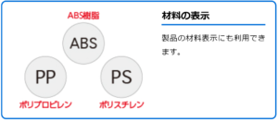  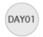  ENGRAVED IDENTIFIERS
Content Examples | DME Mold Component | https://www.dme.net/mdi | https://www.dme. net/catalog/DME/ Mold%20Components/index.html#204
Max. numeric capacity | 72 | 77 | 77 | 6
Max. alphanumeric capacity | 52 | 47 | 47 | 6
Max. binary capacity | 34 | 32 | 32
Error correcting rate | 25% | 7% | 7%

Return to dmeus-csspecials@dme.net or Call 1-800-626-6653 or (248) 398-6000

